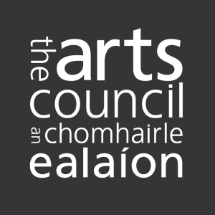

Capacity Building Support Scheme: Report Form

The Arts Council would like to know how the Capacity Building Support Scheme has impacted on your organisation’s work.

Please take some time to complete this form and return it to the Arts Council.

Your information will help us to document and improve the quality of our supports for other artists, and to evaluate their impact relative to our strategic priorities.

Please note the Declaration of Assurance* section at the end of this form. This must be signed by the applicant/s.

Please let us know if we may use information in this report for publication purposes.

Yes
No

Organisation’s name (if group/ consortium, please name all participating organisations)

Amount of award

Application process

Was the application process reasonable (i.e. forms, published criteria, time scale, efficiency)? If not, how could it be improved?

Were the Arts Council’s objectives in making the award clear?

Were the criteria clear and workable?

Were you satisfied with the amount of the award? if not, please detail how this affected your proposal.

Do you have any suggestions for improving the award?

Project Details

Which of the following was your grant awarded for (please tick all that apply)?
1) Digital capability
2) Business and practice development
3) Professional development
4) Developing collaborations and connections
5) Developing capacity for inclusion
6) Other (please describe)

The activities undertaken as a result of this funding will have impacts that are … (please tick all that apply):
1) Short-term
2) Medium-term
3) Long-term

The activities proposed within the application … (please tick one):
1) Were planned/in mind before the announcement of the scheme
2) Were prompted by the priorities of the scheme

Please rank the following according to most acute need in your arts organisation
(1 being of highest priority, 5 being of least priority)
Digital capability
Business and practice development
Professional development
Developing collaborations and connections
Developing capacity for inclusion

If this was a group application, have the activities resulted in any longer-term relationships or partnerships? If so, please describe. If not, please elaborate.

Please describe your aim(s) in making the original application, whether these were realised or whether any changes were made.

What are the immediate impacts of this funding on your organisation’s work? Can you anticipate medium- or even long-term impacts? If so, please describe.

Any other comments?

Declaration of Assurance*

A Declaration of Assurance signed by the applicant and one other responsible person involved with the funded activity is required.

This is to certify that the Arts Council funding was used for the purpose for which it was granted and that any conditions attached to the funding were met. Where the funding is less than €25,000 per annum, the name of the applicant is sufficient.

I certify that the Arts Council funding was used for the purposes for which it was granted and that any conditions attached to the funding were met. Additionally, where I am in receipt of other sources of public funding, I certify there has been no duplication in the use of public funding for the same activity.

Name |  | Date
Name |  | Date

(Typed names are acceptable)

